**VAISHNAVI E 231901059**

**EX. NO: 4B**

**DATE: 05.02.2025**

**RESULTS OF EXAMINATION**

**AIM:**

To print the pass/fail status of a student in a class.

**ALGORITHM:**

1. Read the data from file
2. Get a data from each column
3. Compare the all subject marks column a. If marks less than 45 then print Fail b. else print

Pass

**PROGRAM CODE:**

BEGIN {

print "NAME SUB-1 SUB-2 SUB-3 SUB-4 SUB-5 SUB-6 STATUS";

print "_____________________________________________________________";

}

{ name = $1;

status = "PASS";

for (i = 2; i <= 7; i++) { if ($i < 45) { status = "FAIL";

}

}

print name, $2, $3, $4, $5, $6, $7, status;

}

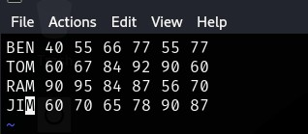

**CSE-CYBER SECURITY**

**PRIYANGA M 231901037**

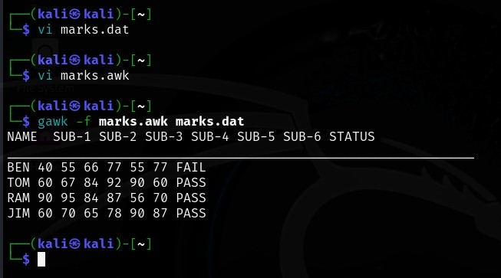

**RESULT:**

Hence, mark status details using awk script is executed successfully.

**CSE-CYBER SECURITY**